**Documentation of Sources**

Code resources:

<https://www.w3schools.com/howto/howto_js_mobile_navbar.asp>

* To create a burger navigation menu

<https://cdnjs.cloudflare.com/ajax/libs/font-awesome/4.7.0/css/font-awesome.min.css>

* Creates burger navigation icon

<https://getbootstrap.com/>

* Used to make my website responsive

<https://www.geeksforgeeks.org/how-to-use-image-overlay-correctly-with-bootstrap/>

* Used to overlay text on images

<https://www.toptal.com/designers/htmlarrows/symbols/copyright-sign/>

* Used to create copyright mark

<https://stackoverflow.com/questions/48594622/multiple-drop-down-button-list-javascript>

* Sitemap dropdown boxes

<https://getbootstrap.com/docs/4.0/content/tables/>

* Table for class timetable

Photos used:



<https://www.openaccessgovernment.org/widening-options-for-adult-learners/54350/>



<https://komodomath.com/blog/how-to-support-childrens-learning>

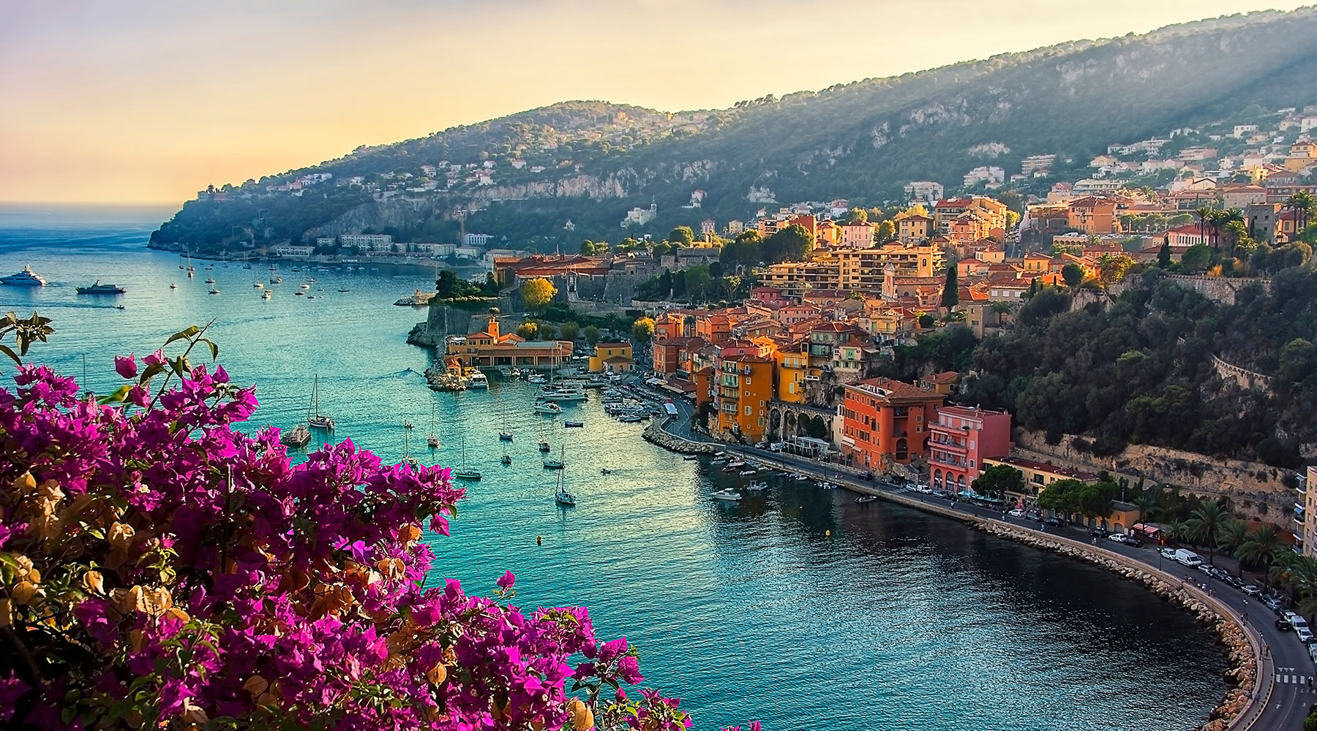

https://www.azamara.com/ie/nice-villefranche-france-cruises

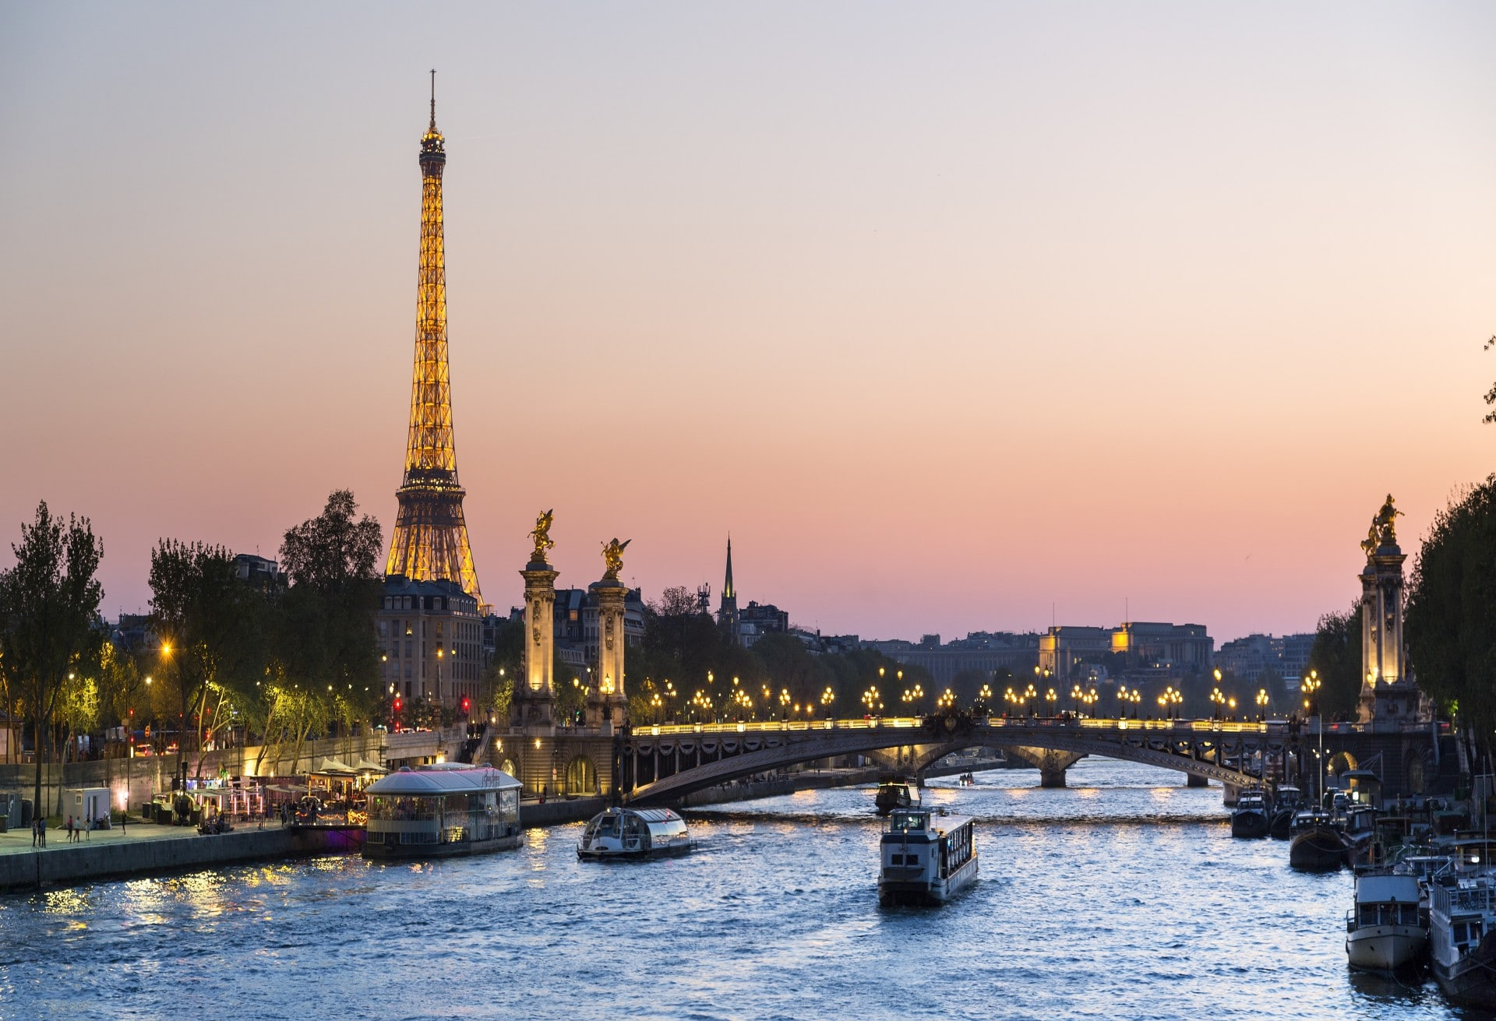

<https://rivierabarcrawltours.com/paris-tour-guide-jobs/>

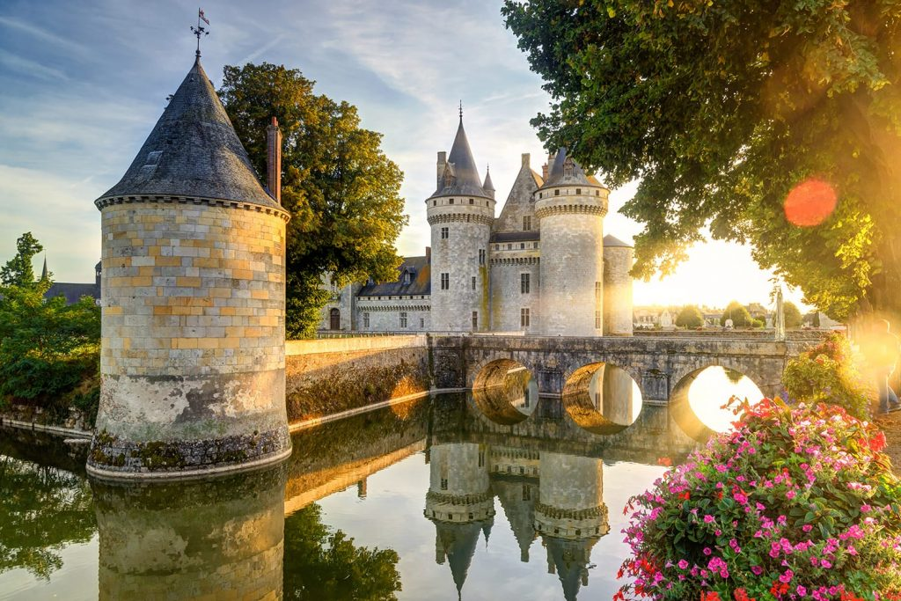

<https://www.roadaffair.com/visiting-loire-valley-from-paris/>

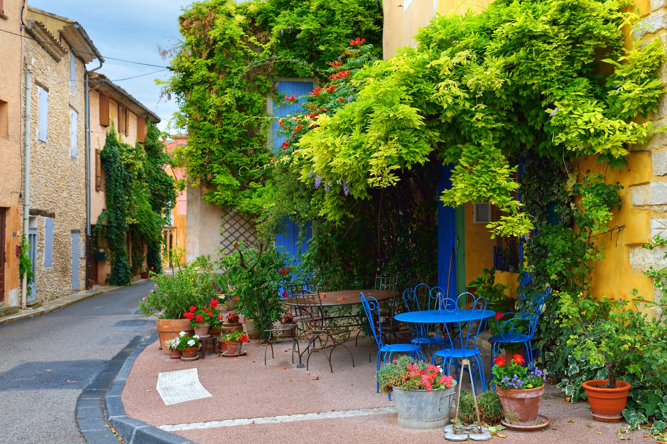

<https://travelmamas.com/provence-with-kids-a-dream-come-true/>



<https://www.cntraveler.com/galleries/2014-10-15/10-things-not-to-do-in-paris>

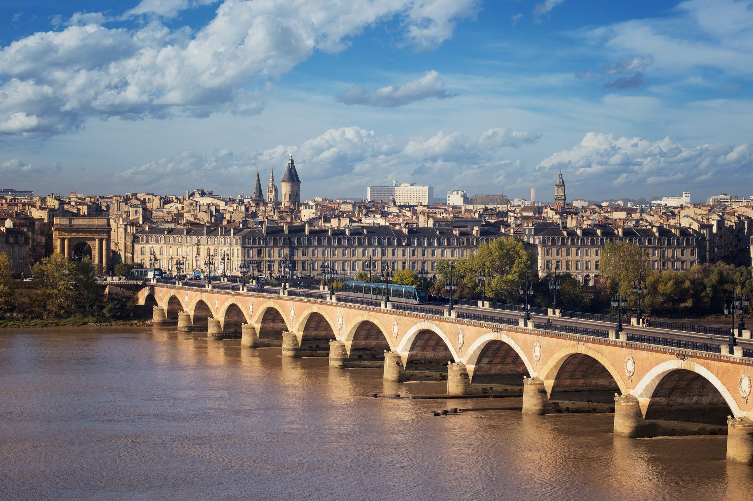

<https://www.townandcountrymag.com/leisure/travel-guide/a29437290/what-to-do-in-bordeaux-france/>

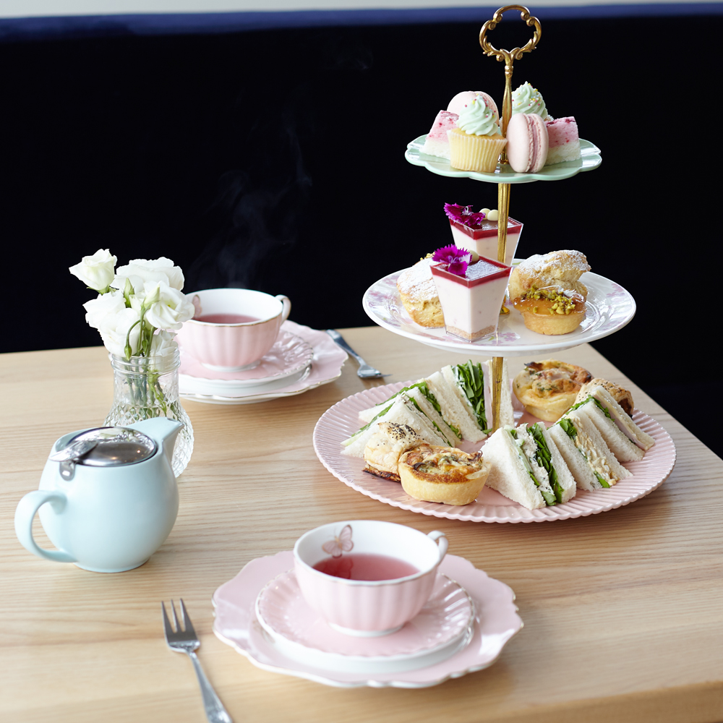

https://shopify_rilo.s3.amazonaws.com/shops%2F1533509169977-Insta_Hightea2018_004.jpg

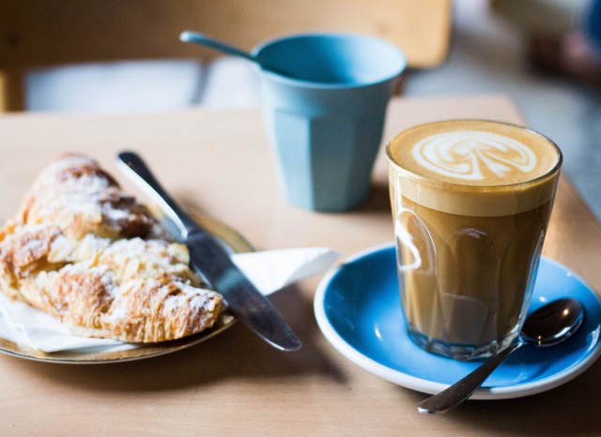

https://perfectdailygrind.com/2019/09/how-to-create-a-coffee-shop-food-menu-that-minimises-waste/

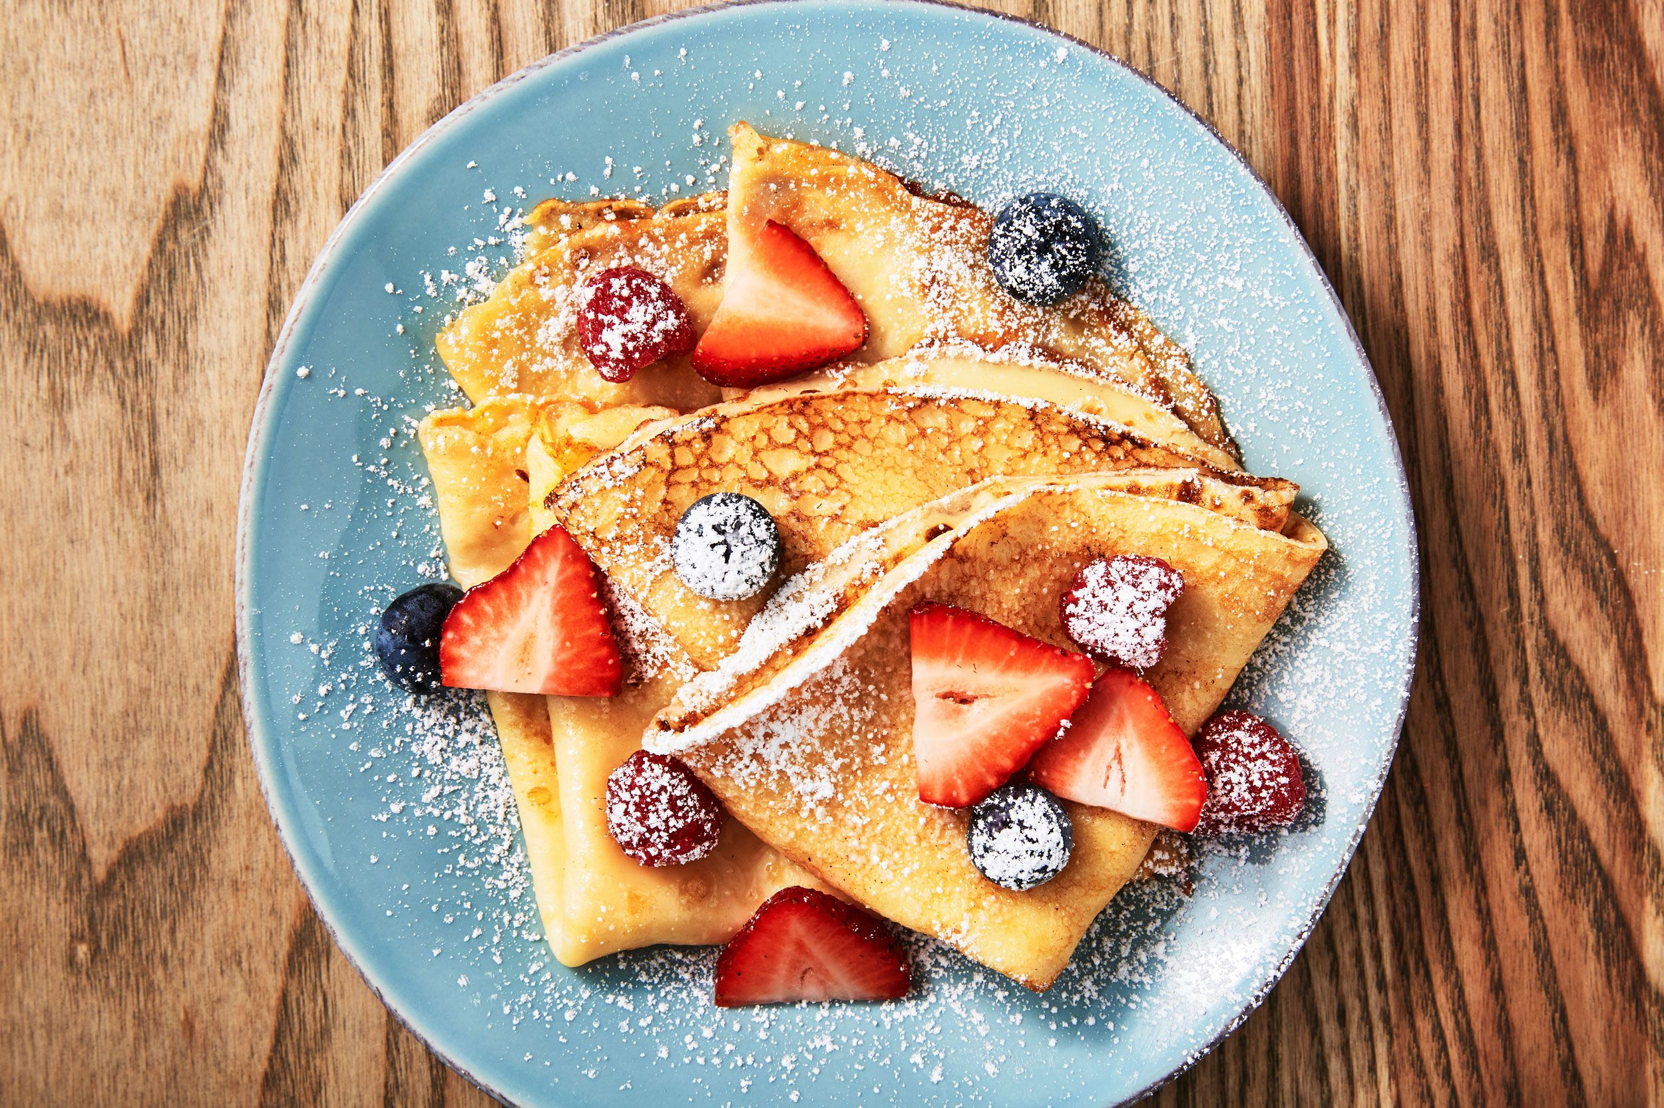

https://www.delish.com/cooking/recipe-ideas/recipes/a52114/easy-basic-crepe-recipe/

Text Resource:

<https://www.alliance-francaise.co.nz/learn-french/test-your-level/>

<https://www.afdunedin.org.nz/DELF>